SOFTWARE TESTING PRACTICAL REPORT
GeeksforGeeks – Profile Edit Field Validation
Equivalence Partitioning (EP) & Boundary Value Analysis (BVA)

1. Aim
To apply Equivalence Partitioning (EP) and Boundary Value Analysis (BVA) to visible fields on the GeeksforGeeks Profile Edit page, record observed validation/counter behavior from the supplied screenshots, and prepare test cases and a test report.

2. Application and Scope
Application: GeeksforGeeks website. Module: Profile Edit. Fields covered: Phone Number, Name, Headline, and About/Bio. This practical is limited to field-level behavior visible in the screenshots; successful saving/updating of the profile is not shown.

3. Test Environment
Parameter | Details
Application | GeeksforGeeks Profile Edit page
Browser / Platform | Google Chrome on Windows desktop (as visible in screenshots)
Techniques | Equivalence Partitioning (EP) and Boundary Value Analysis (BVA)
Evidence | 10 screenshots supplied by the user
Scope limitation | Only displayed values, character counters, and phone required-field message can be verified.

4. Equivalence Partitioning (EP)
EP divides inputs into representative groups expected to behave similarly. The supplied screenshots show an empty required phone field, a 10-character phone value, a 12-character phone value, normal/maximum-length Name and Headline values, and Bio values below and at the displayed limit.
ID | Field / Class | Representative input | Expected result | Observed result / status
EP-01 | Phone – empty required field | Empty | Required validation shown | “Phone number is required.” — Pass
EP-02 | Phone – entered value | 10 digits shown | Value reflected by counter | 10/12 — Pass (field-level only)
EP-03 | Phone – displayed limit | 12 characters shown | Counter reaches 12/12 | 12/12 — Pass (field-level only)
EP-04 | Name – normal input | Piyush Gewani C | Value fits field limit | 15/50 — Pass (field-level only)
EP-05 | Headline – maximum displayed length | 50 characters | Counter reaches 50/50 | 50/50 — Pass (field-level only)
EP-06 | Bio – below limit | 210 characters | Counter remains below 300 | 210/300 — Pass (field-level only)
EP-07 | Bio – maximum displayed length | 300 characters | Counter reaches 300/300 | 300/300 — Pass (field-level only)

5. Boundary Value Analysis (BVA)
The screenshots display limits of 12 characters for Phone Number, 50 characters for Name, 50 characters for Headline, and 300 characters for About/Bio. Values at the displayed maximum are visible for these fields. Maximum + 1 inputs were not captured, so enforcement beyond the limit remains unverified.
Field | Boundary case | Input length | Observed result | Status
Phone Number | Empty required boundary | 0 | Required message shown | Pass
Phone Number | At displayed limit | 12 | 12/12 shown | Pass (field-level only)
Phone Number | Maximum + 1 | 13 | Not captured | Not Executed
Name | At maximum | 50 | 50/50 shown | Pass (field-level only)
Name | Maximum + 1 | 51 | Not captured | Not Executed
Headline | At maximum | 50 | 50/50 shown | Pass (field-level only)
Headline | Maximum + 1 | 51 | Not captured | Not Executed
About/Bio | At maximum | 300 | 300/300 shown | Pass (field-level only)
About/Bio | Maximum + 1 | 301 | Not captured | Not Executed

6. Test Cases and Execution
Test Case ID | Technique | Module / Scenario | Actual result | Status
TC-GFG-EP-01 | EP | Edit Profile - Phone – Leave required phone number empty and trigger validation | “Phone number is required.” is visible in red | Pass
TC-GFG-EP-02 | EP | Edit Profile - Phone – Enter a 10-digit phone number | 10/12 character counter shown; no phone error visible | Pass (field-level only)
TC-GFG-EP-03 | EP | Edit Profile - Phone – Enter a 12-digit phone value | 12/12 counter shown | Pass (field-level only)
TC-GFG-EP-04 | EP | Edit Profile - Name – Enter a normal name | “Piyush Gewani C”; 15/50 shown | Pass (field-level only)
TC-GFG-EP-05 | EP | Edit Profile - Headline – Leave required headline empty | Headline field shows 0/50; submit result not shown | Not Executed (submit validation)
TC-GFG-EP-06 | EP | Edit Profile - Headline – Enter a headline at the displayed 50-character limit | Counter displays 50/50 | Pass (field-level only)
TC-GFG-EP-07 | EP | Edit Profile - Bio – Leave required bio empty | Bio field shows 0/300; submit result not shown | Not Executed (submit validation)
TC-GFG-EP-08 | EP | Edit Profile - Bio – Enter a bio below the limit | Counter displays 210/300 | Pass (field-level only)
TC-GFG-EP-09 | EP | Edit Profile - Bio – Enter a bio at the displayed 300-character limit | Counter displays 300/300 | Pass (field-level only)
TC-GFG-BVA-01 | BVA | Edit Profile - Phone – Boundary low: empty phone value (0 characters) | “Phone number is required.” is visible | Pass
TC-GFG-BVA-02 | BVA | Edit Profile - Phone – Boundary representative: 10-digit phone value | 10/12 shown | Pass (field-level only)
TC-GFG-BVA-03 | BVA | Edit Profile - Phone – Upper displayed limit: 12 characters | 12/12 shown; 13-character test not captured | Not Executed (13-char case)
TC-GFG-BVA-04 | BVA | Edit Profile - Name – Maximum boundary: 50 characters | 50/50 shown | Pass (field-level only)
TC-GFG-BVA-05 | BVA | Edit Profile - Name – Maximum + 1: 51 characters | No 51-character screenshot supplied | Not Executed
TC-GFG-BVA-06 | BVA | Edit Profile - Headline – Maximum boundary: 50 characters | 50/50 shown | Pass (field-level only)
TC-GFG-BVA-07 | BVA | Edit Profile - Headline – Maximum + 1: 51 characters | No 51-character screenshot supplied | Not Executed
TC-GFG-BVA-08 | BVA | Edit Profile - Bio – Maximum boundary: 300 characters | 300/300 shown | Pass (field-level only)
TC-GFG-BVA-09 | BVA | Edit Profile - Bio – Maximum + 1: 301 characters | No 301-character screenshot supplied | Not Executed

7. Bug Report
Bug ID | Module | Finding | Status
BUG-GFG-001 | Profile Edit – Phone | No confirmed defect in the supplied evidence: empty phone field displays required-field validation. | No Defect Found in supplied evidence
BUG-GFG-002 | Name / Headline / Bio / Phone | Maximum + 1 behavior has not been tested. No defect should be declared until the input is executed and observed. | Pending execution

8. Observations
ID | Observation
OBS-01 | Phone Number: The field shows a 0/12 counter and the message “Phone number is required.” when empty. Evidence: Screenshot 171/172
OBS-02 | Phone Number: A 10-digit value is shown with counter 10/12. Evidence: Screenshot 174
OBS-03 | Phone Number: A 12-character value is shown with counter 12/12. Evidence: Screenshot 173
OBS-04 | Name: The name field displays a 15/50 counter with a normal name. Evidence: Screenshot 173
OBS-05 | Name: A long name reaches the 50/50 displayed limit. Evidence: Screenshot 171
OBS-06 | Headline: The headline counter is shown at 0/50, 17/50 and 50/50 across screenshots. Evidence: Screenshots 176–179
OBS-07 | About/Bio: The bio counter is shown at 0/300, 210/300 and 300/300. Evidence: Screenshots 176, 179, 180
OBS-08 | Form submission: Screenshots show field values/counters and phone required validation, but do not show a successful Save/Update result. Evidence: Screenshots supplied

9. Screenshot Evidence
The screenshots below are referenced by their original screenshot numbers. Some screenshots show the same field in different states; they are used as evidence of counters and visible validation, not as proof that the profile was successfully saved.

Screenshot 1 – Profile edit form; long name 50/50 and empty phone required message
Evidence file: Screenshot (171).png
Use: Name boundary; phone required validation
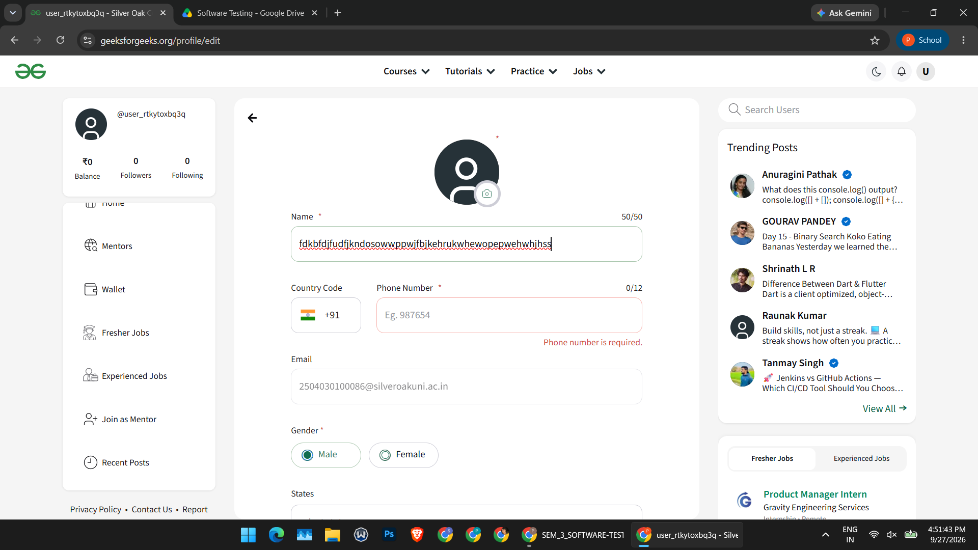

Screenshot 2 – Name normal; empty phone required message
Evidence file: Screenshot (172).png
Use: Phone required validation
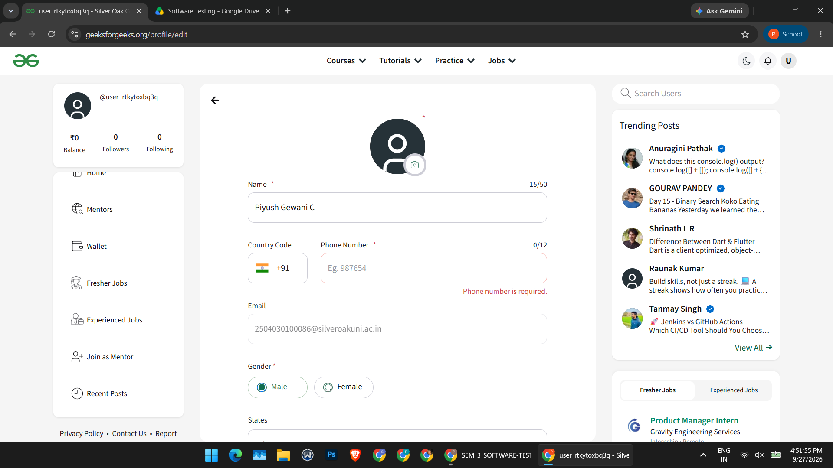

Screenshot 3 – Name 15/50; phone 12/12
Evidence file: Screenshot (173).png
Use: Normal name and phone upper displayed count
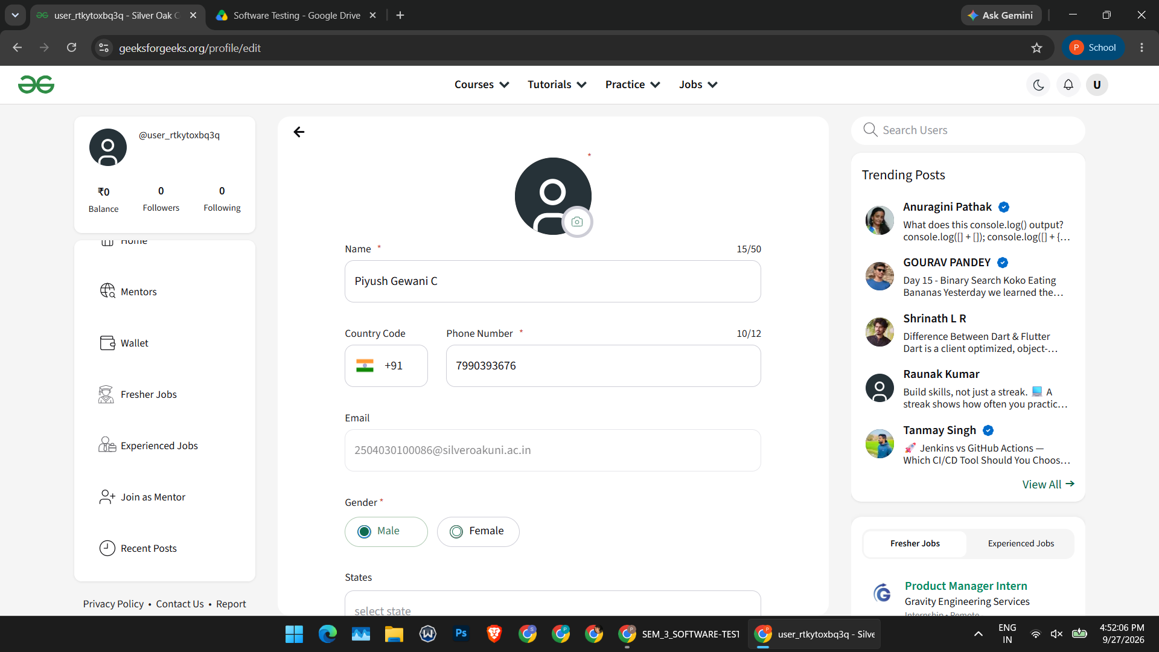

Screenshot 4 – Phone 10/12
Evidence file: Screenshot (174).png
Use: Phone representative length
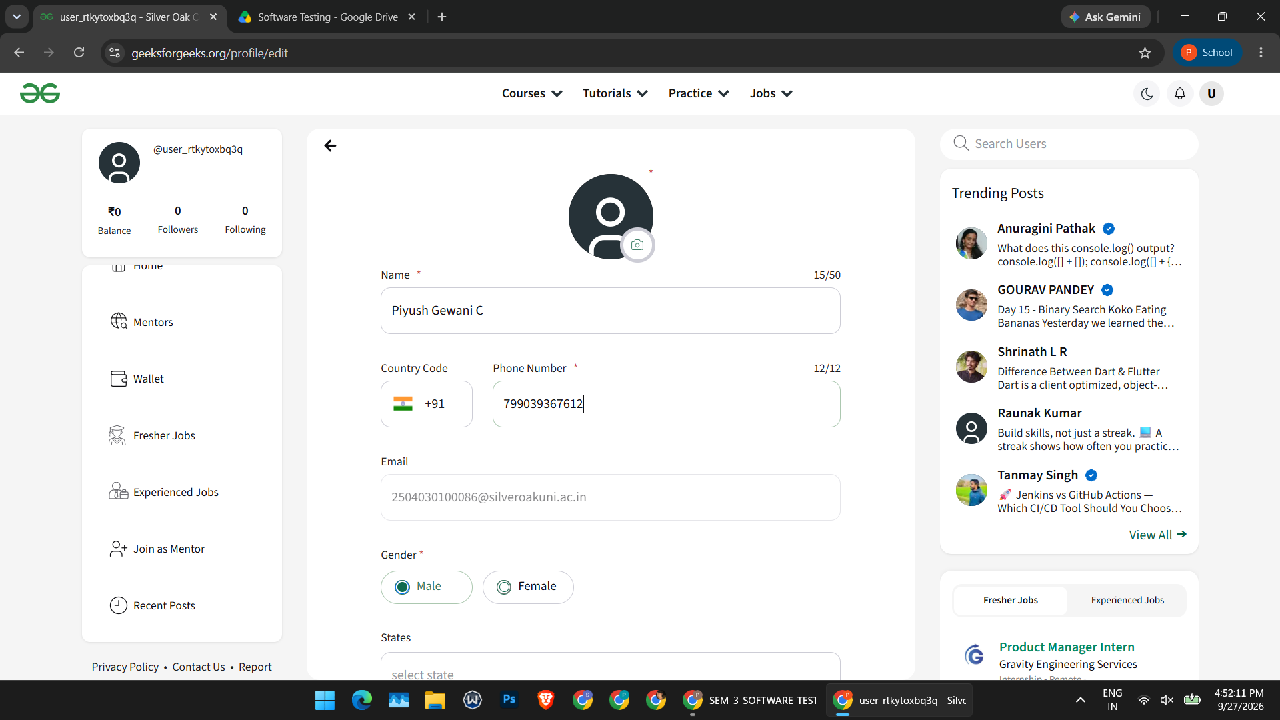

Screenshot 5 – Headline contains long invalid-looking text at 50/50
Evidence file: Screenshot (175).png
Use: Headline counter maximum; no content validation confirmed
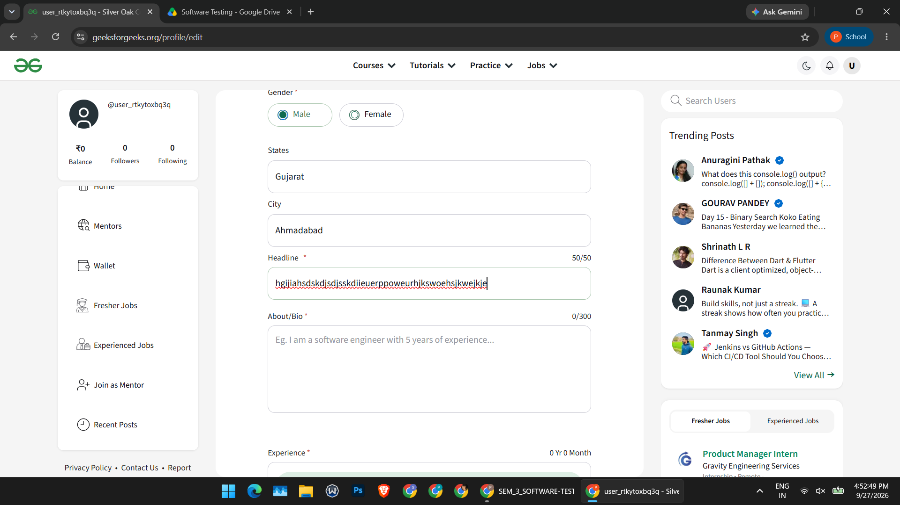

Screenshot 6 – Headline 0/50 and Bio 0/300
Evidence file: Screenshot (176).png
Use: Empty required fields visible; submission behavior not shown
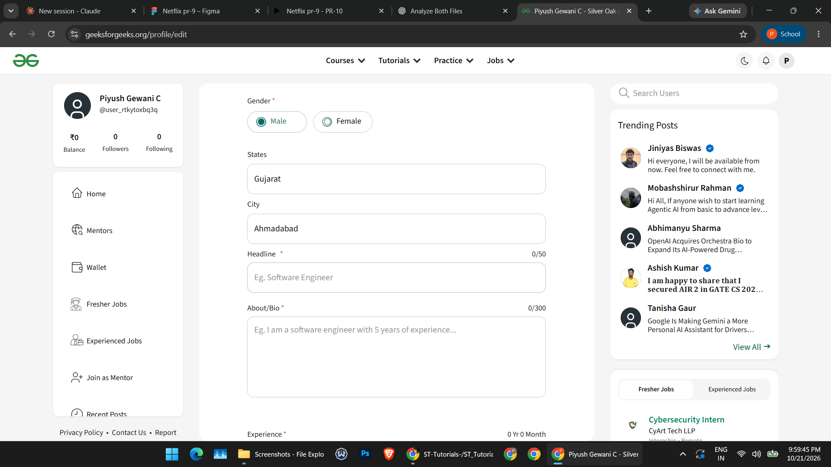

Screenshot 7 – Headline 17/50
Evidence file: Screenshot (177).png
Use: Headline below limit
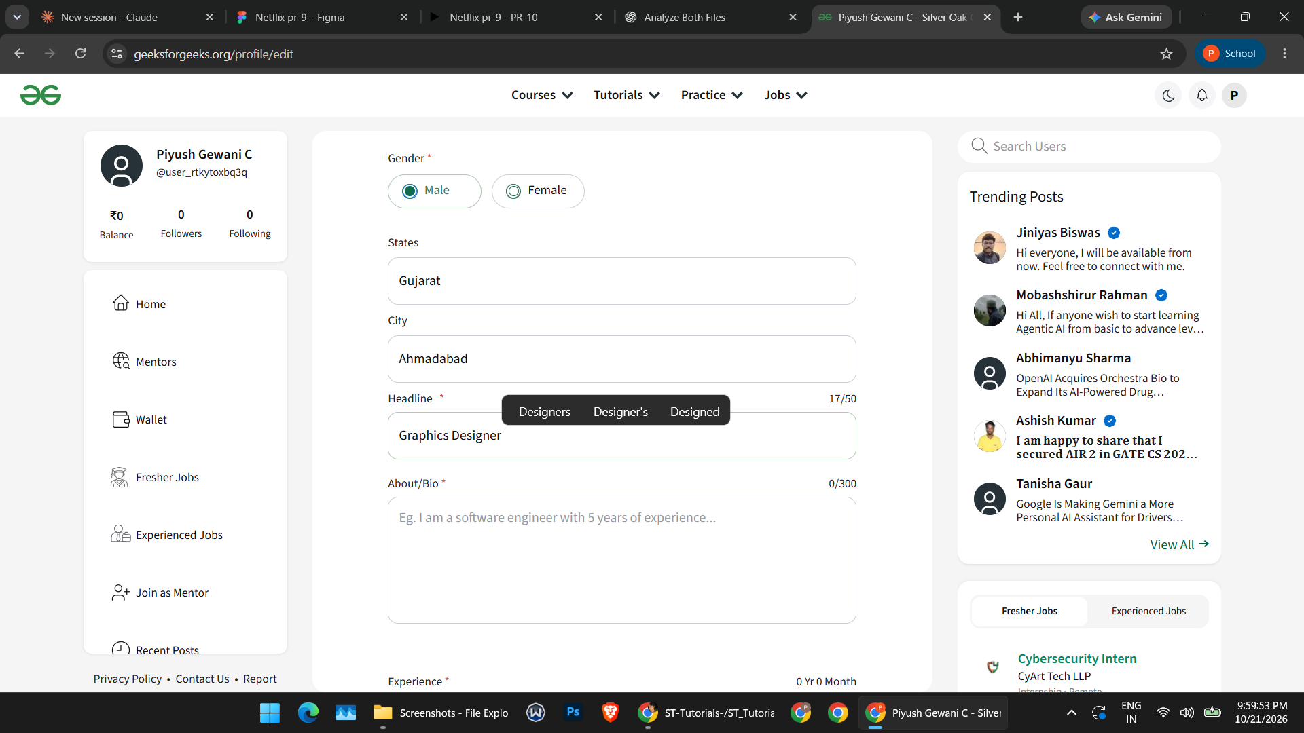

Screenshot 8 – Headline 50/50
Evidence file: Screenshot (178).png
Use: Headline maximum displayed count
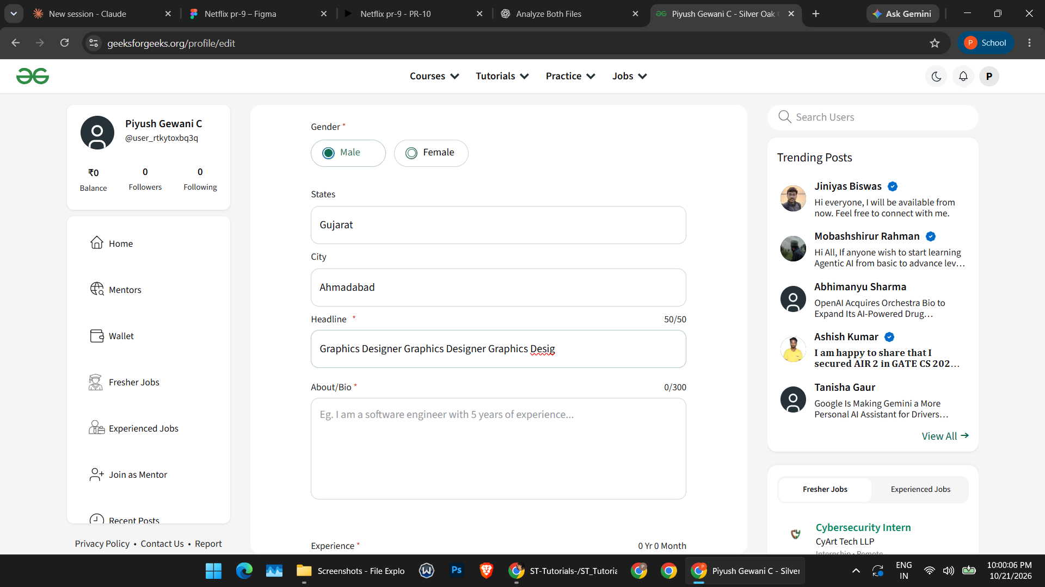

Screenshot 9 – Bio 210/300 and headline 50/50
Evidence file: Screenshot (179).png
Use: Bio below limit
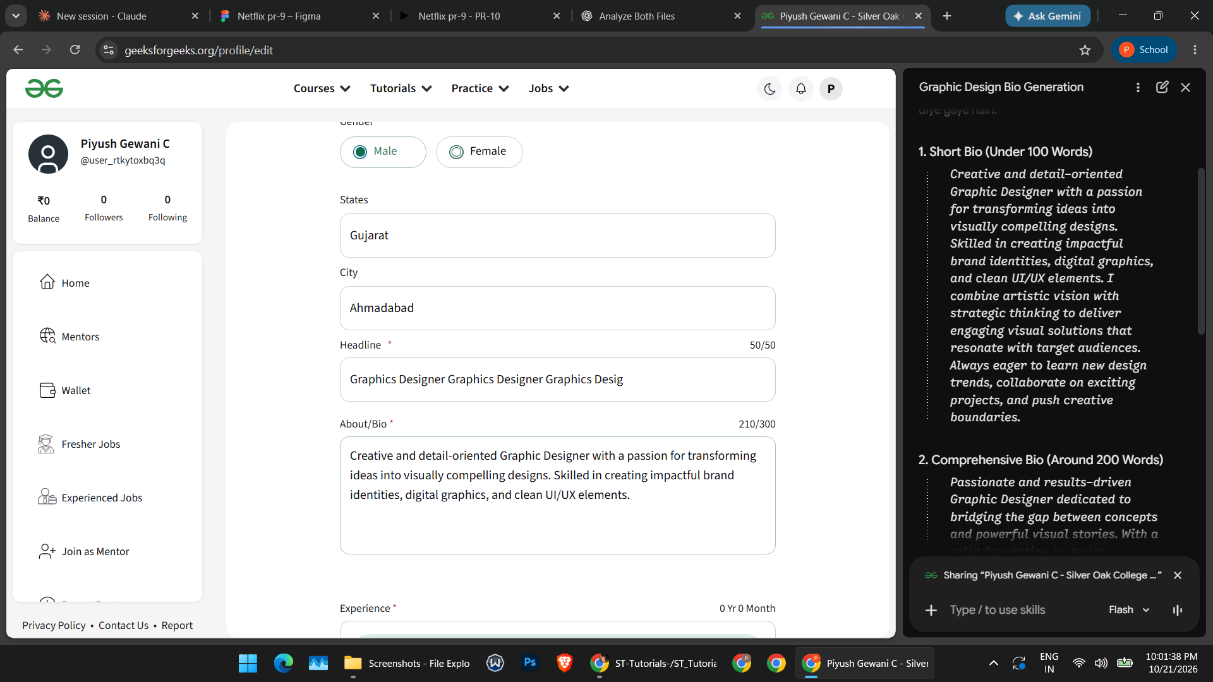

Screenshot 10 – Bio 300/300
Evidence file: Screenshot (180).png
Use: Bio maximum displayed count
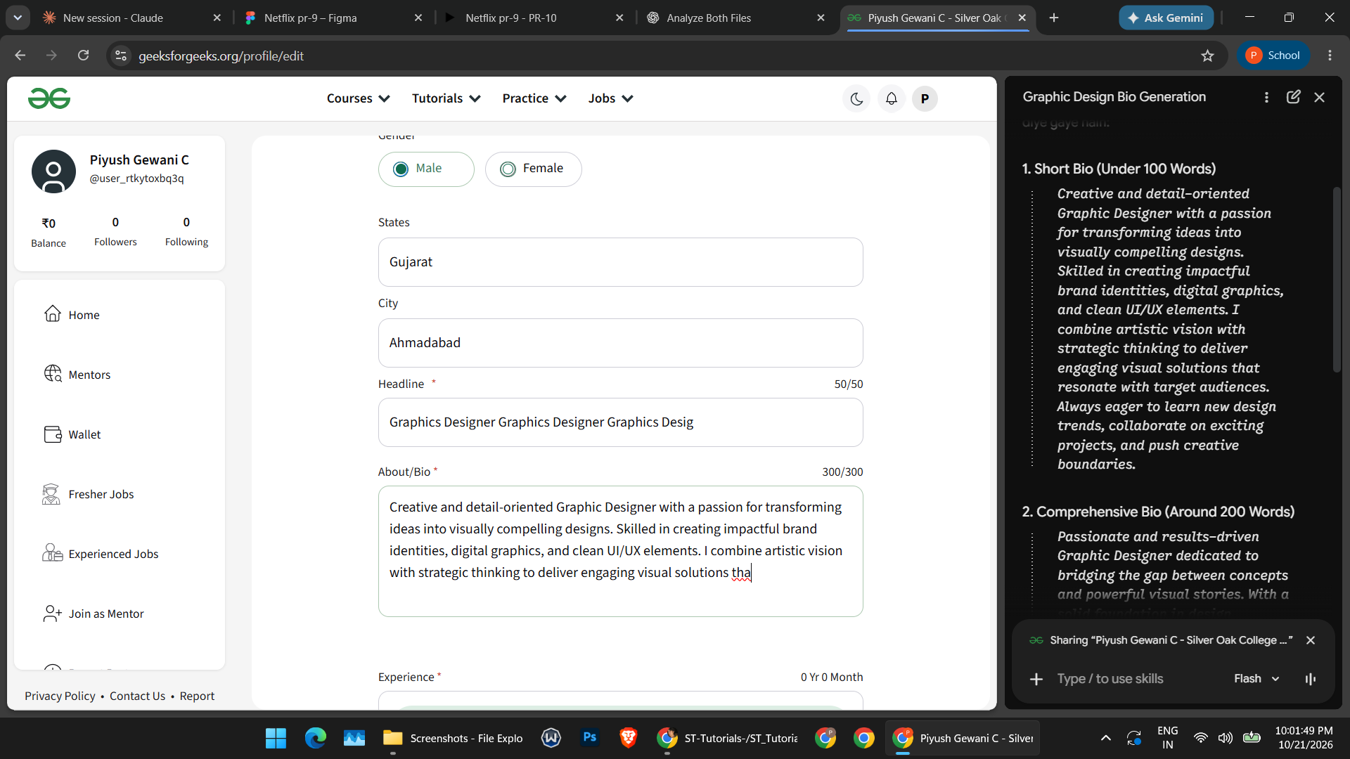

10. Conclusion / Outcome
Equivalence Partitioning was applied to representative input classes for Phone Number, Name, Headline, and About/Bio. Boundary Value Analysis was applied to the displayed character limits: 12 for Phone Number, 50 for Name, 50 for Headline, and 300 for About/Bio. The screenshots confirm the phone required-field message and show counters at or below the displayed limits. Maximum + 1 cases and successful profile submission were not evidenced, so those behaviors remain unverified. No confirmed defect can be concluded from the supplied screenshots.

